2311104034  
Maulana Kaka Halin Widyadhana  
SE-07-01

Jurnal dan TP Modul 02

Jurnal

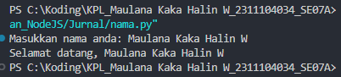

TP

